Transfigured Night

Student’s Name
Department, University
Course Number and Name
Instructor’s Name
Date

Transfigured Night
Vincent van Gogh's night sky is a peaceful night in the country. The moon, a church, and a cypress tree. Rest seems unlikely beneath the angry sky. With its huge scars, Vincent painted this nightscape in a lunatic asylum and killed himself a year before. Was this a rebellious cry of a genius ahead of his time? In his picture, the spontaneous product of insanity. Vans nightscape dates 1889, it is inspired by a string of popular handbooks which has the first-ever picture of the night sky, it is an astronomy which is attracting amateur enthusiasts (Canal Educatif à la Demande (CED), 2013). A real nebula is what the spiral is based on. The moon is just as the artist might have seen it from the side of his view before morning in 1889. The view at Vans window stops short at a wall, he invents a landscape with cypress and the village stipple which give the picture depth and structure ("Starry night," n.d.). The wild viral keys in the waning point straight below it. If saneness rules the configuration, then madness powers the stormy brushwork.
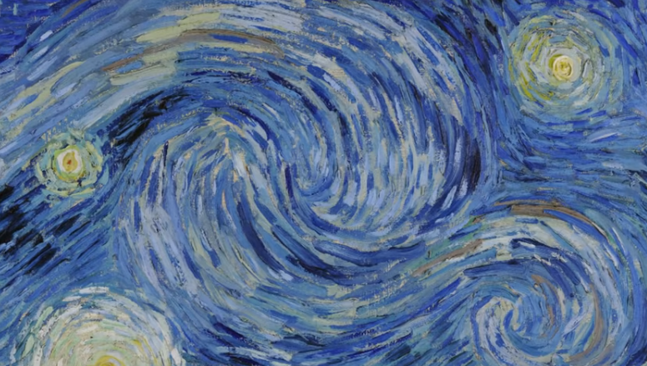
Fig: The beauty of the sky with its stars
Van is working so wild that he shrubbery the part of the work unembellished. His treatment of the paint reinforces the contrast between the pictures into splits. At the lowermost, the houses are outlined in black like the data in a bright tainted glass. The tress resembles dense skeins of wool, the earth has a carved solidity and the sky swirls and surges like a shoal of fish, and the starlight spreads outward in concentric waves (Canal Educatif à la Demande (CED), 2013). The picture pulsing movement is a conscious effect, which Van used to bring out the difference in the middle of the earth's concrete sturdiness and the sky wave-like dynamism. The cypress acquaintances them like a bridge ("Starry night," n.d.). Viscous as a star, vibrant as flame, why did Van pump all this drama into a potential peaceful nightscape?
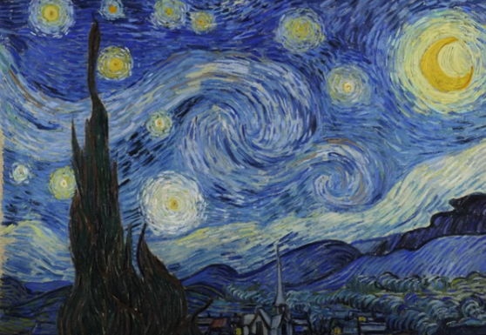
Fig: Peaceful sky, stars, homes and a tree
Van's vision of night as a star-filled sky has been proceeded by another. The night is a time of release after the day's work is done. Van takes a different line, he sees the nobility of the peasant's dimly late meal and the bright city's' dehumanizing effect on its denizens. At first glance, primitive and gloomy, the mealtime scene with the eaters exchanging words and looks in a single lamp-consoling glow is a celebration of well-earned rest from labor; the house is united as if those small houses clustered around a single steeple, which stands the Christian belief. Van celebrates the simple peasant's dignity like his predecessor Jean- Francois Millet (Canal Educatif à la Demande (CED), 2013). The sense of the communion of heaven and earth make Van view the life in the city as visions of hell. In the dance ballroom in the Arles, the light that brings people laidback is gone and a cloud of dim lamps has taken over. Individual dancers seem lost in the whirling hysterical throng. The simple dignity and celebrations seem to be lost in the city with everybody chasing something that they never seem to be satisfied with ("Starry night," n.d.). Leaving behind the impression of dignity and celebration, Van made his work a hallmark for all succeeding expressionist paintings.
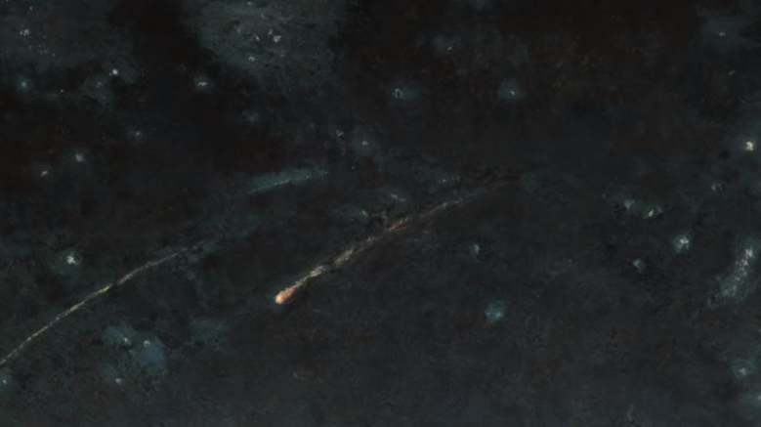
Fig: At night
References
Canal Educatif à la Demande (CED). (2013, June 14). ArtSleuth 1 : VAN GOGH - The Starry Night (final version) - MOMA. YouTube. https://www.youtube.com/watch?v=48v5YUTaiVU&feature=youtu.be
The Starry night. (n.d.). Google Arts & Culture. https://artsandculture.google.com/asset/the-starry-night/bgEuwDxel93-Pg?hl=en&ms=%7B%22x%22%3A0.5%2C%22y%22%3A0.5%2C%22z%22%3A9.507015821651676%2C%22size%22%3A%7B%22width%22%3A1.9244683926680548%2C%22height%22%3A1.2375000000000005%7D%7D

